We are trying to install node.js on the virtual machine, as the application that was made from AI studio. It had given runs on node.
After installing node to the local machine via a download from the official node website: https://nodejs.org/en/download/
The following error message occurred after trying to run any sort of node script.
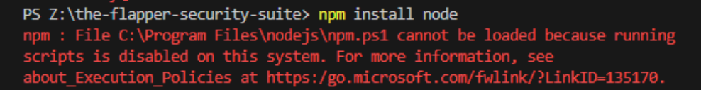
A funny error that I cannot run ANY scripts on this virtual machine.
I have solved it by:
First trying to see, What is getting blocked
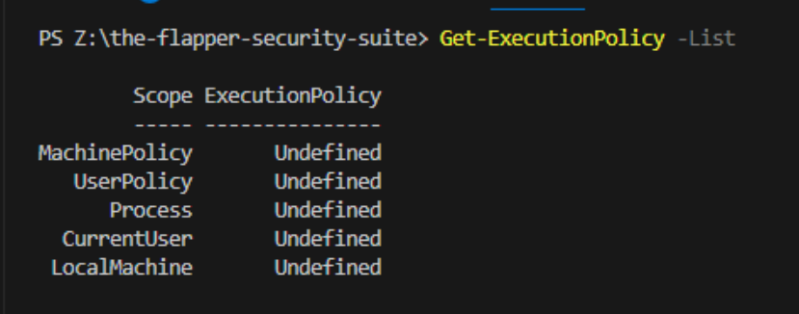
I then ran the following terminal command
“Set-ExecutionPolicy -Scope CurrentUser -ExecutionPolicy RemoteSigned”
Where it should allow the current user to be remote signed, to allow the use of scripts
If we check for it, it should show as “CurrentUser RemotSigned”
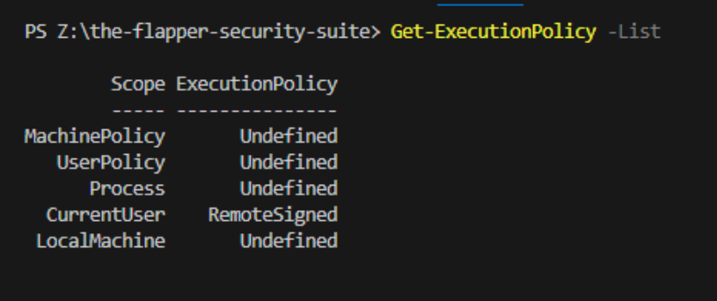

After the sort, I can now install node itself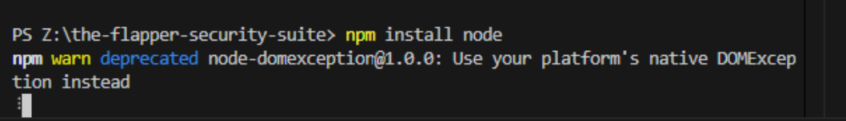
BUT as it is stated in the warn, MY NODE INSTALL ID DEPRACTED. Which means, my node.js did not install correctly

So I am now running the node installer repair tool hoping that it works
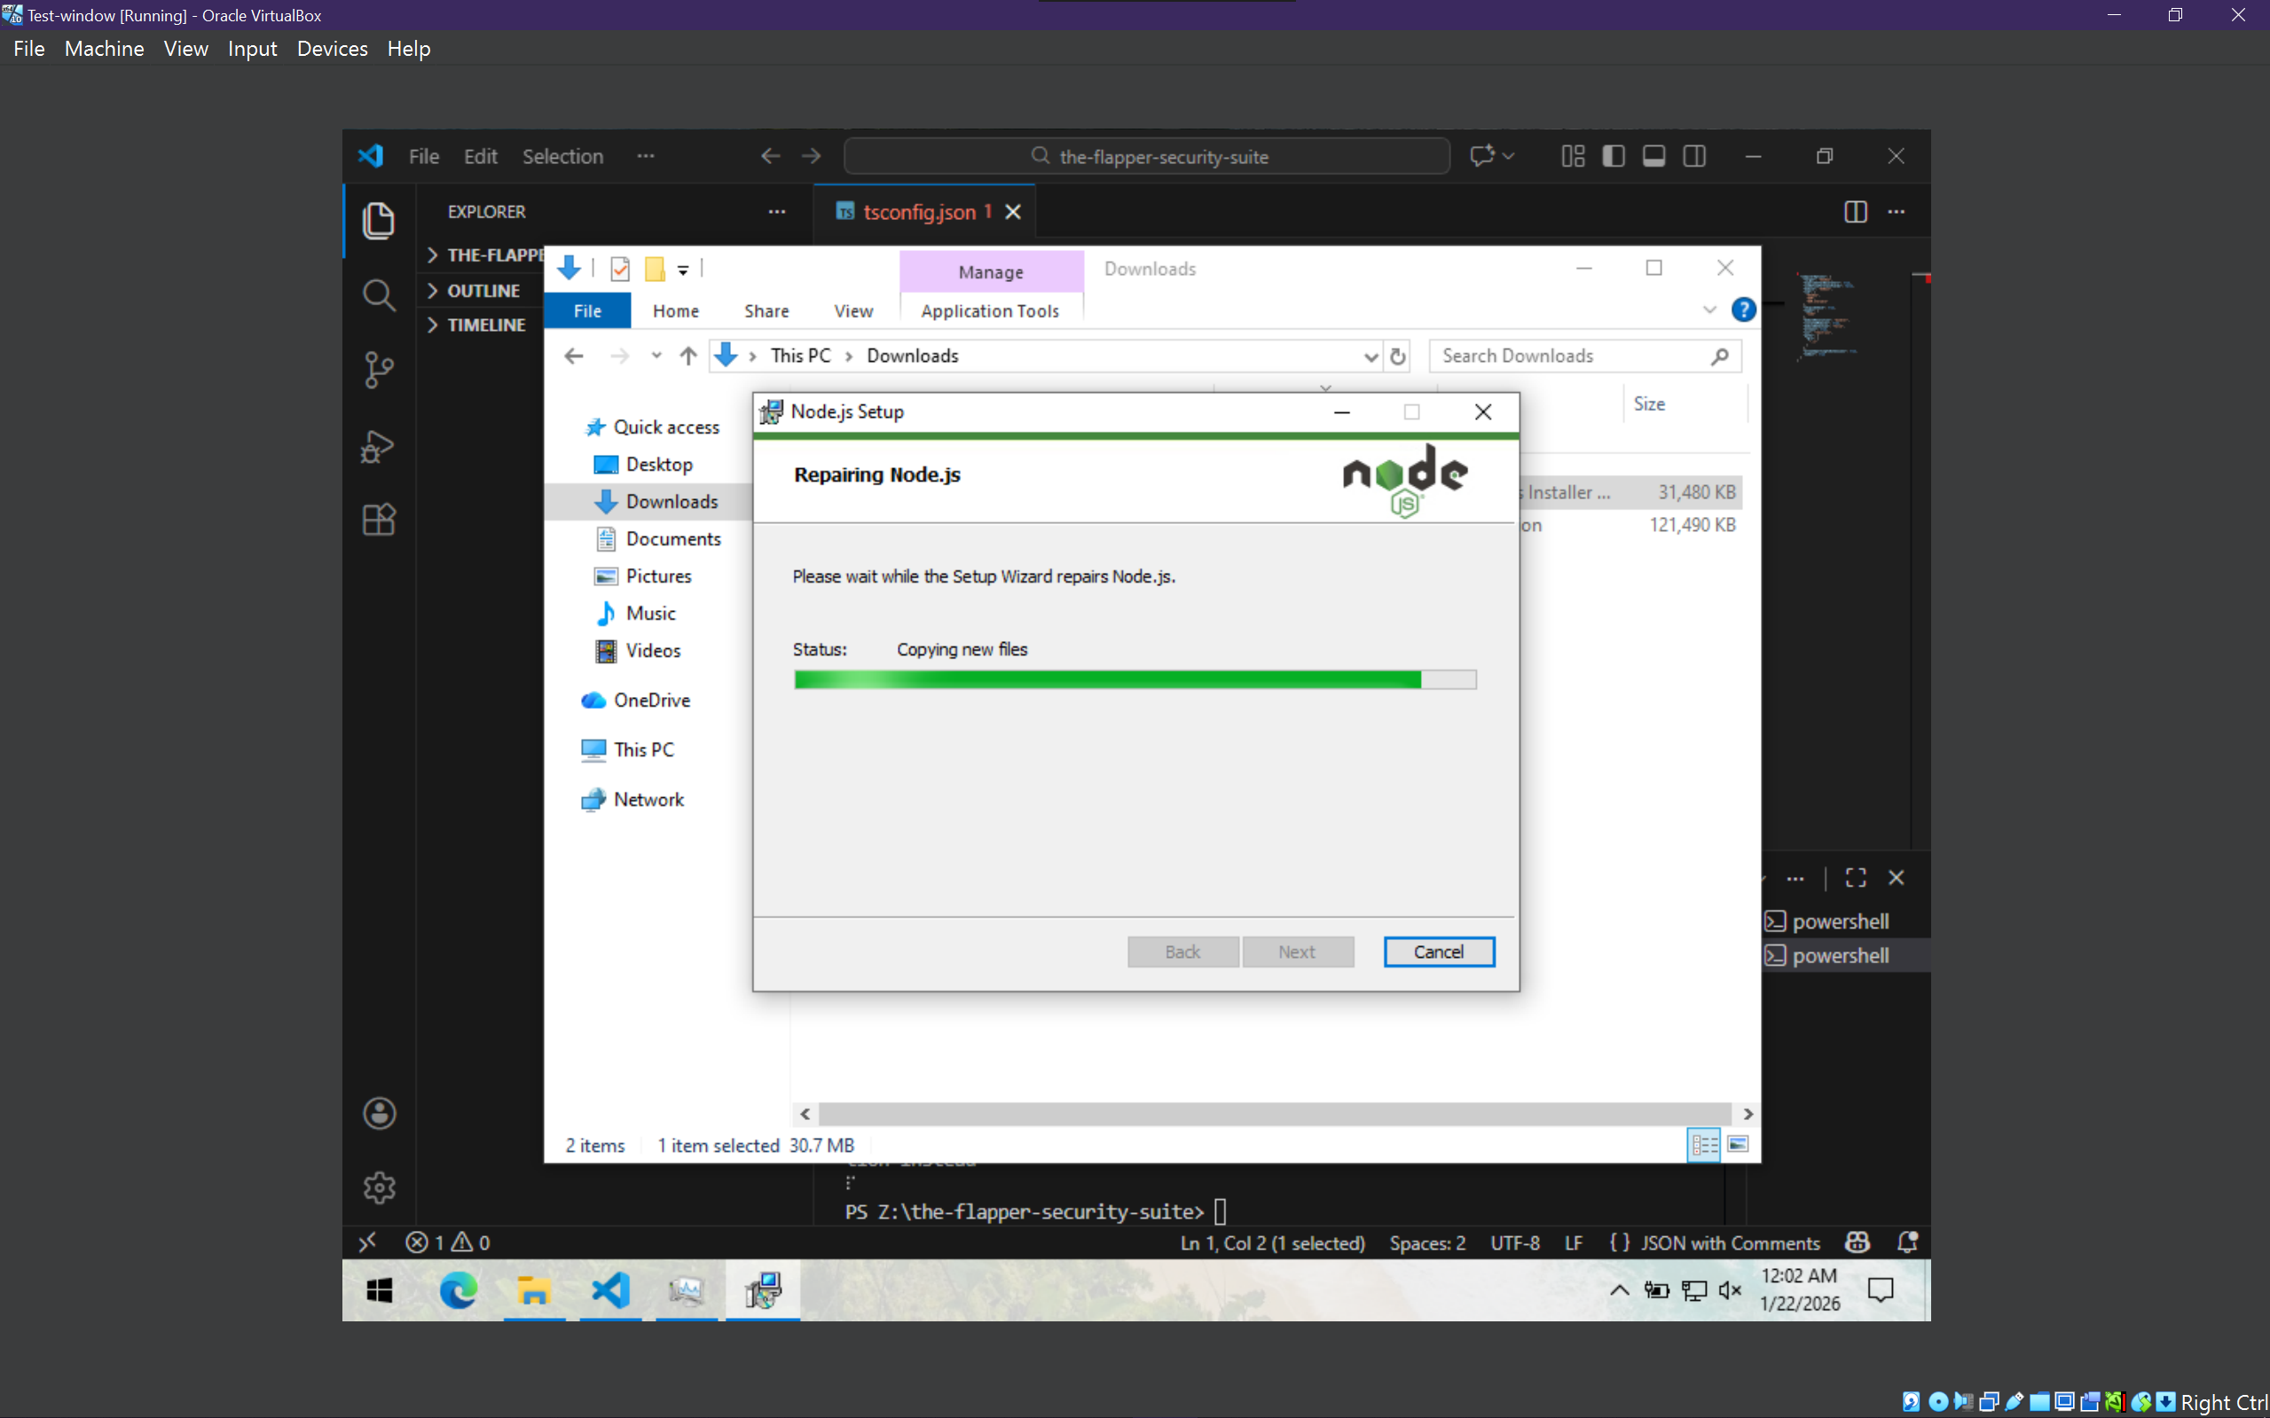
After trying again on vscode, it failed to install. Looking at the code, it says that there is an error
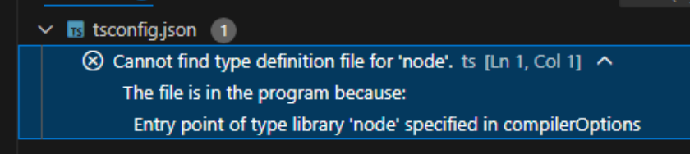
To fix it I had done the following:
“npm install --save-dev @types/node”
And restarted vscode
As that alone installs the dev type looking for node

After trying to run the actual application via the shared folder, it would run into an issue of it seeing a certain file as a folder.

But after moving the entire folder that holds the project locally. It had ran without issues

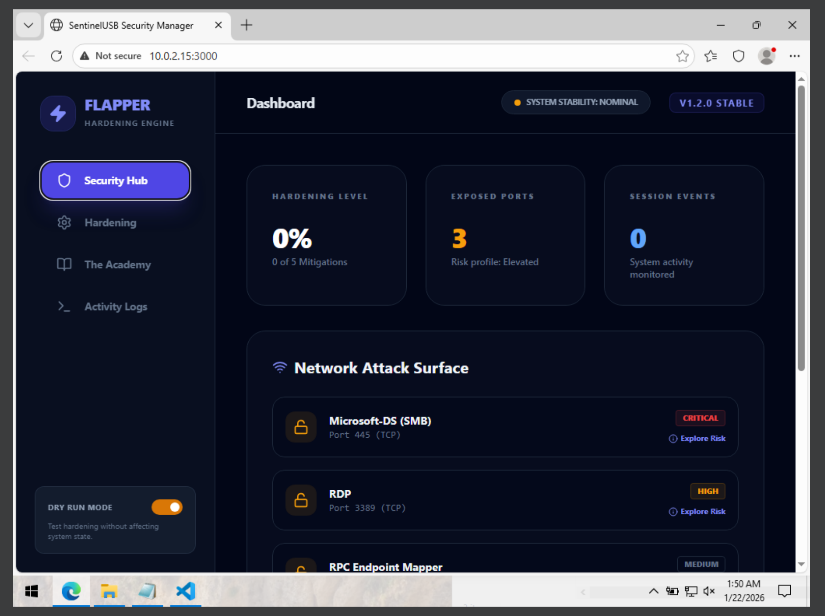

Having gotten feedback from a person, I know that can code. They have said the following:
“That’s not really good, I don’t like that”
But after a bit they followed with
“I am going to have to accept that it’ll be used more for experience coders, as I am trying to implement it myself”
As I found that interesting, comparing a coder to a noncoder.
Its sole base on how much you use AI to your advantage. Since if you use it as a crutch, you will rarely get far. But if you use it and learn from it, you gain more overall knowledge as it pertains to certain fields of expertise for people who do purely IT, IS, Cybersecurity, SE, TM, Game Dev, etc.
It all just matters on how it is being used in the context of where it is being based off.

Testing to see if SMBv1 is enabled on the vm
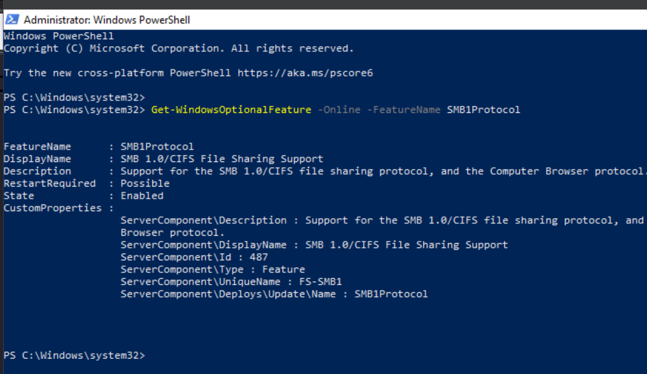

Seeing if the application does work with its actions
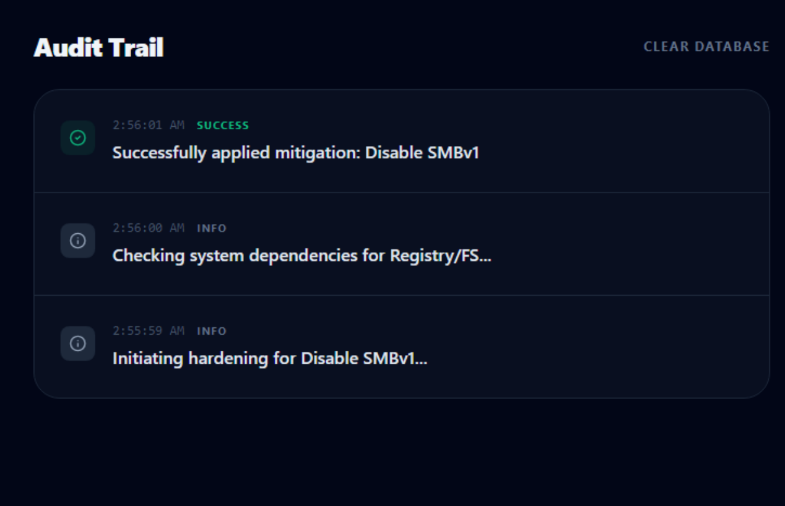

It does not actually disable the protocol
